My SQL Task-2

Design DB model for Guvi Zen class

Query For Design DB model for Guvi Zen class

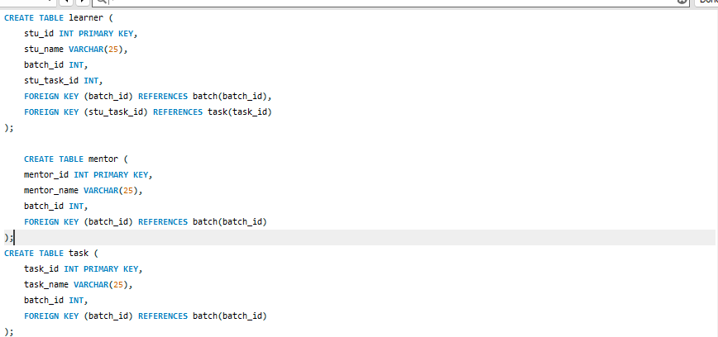

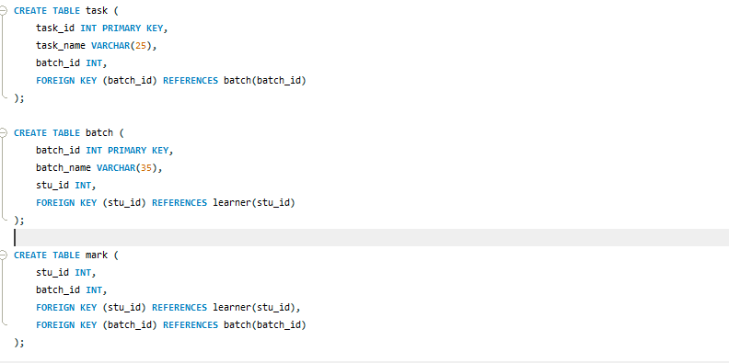

Design DB model for Guvi Zen class

